Part B (Q2) Implement a Standard ACL
Problem Statement
Configure a Standard ACL on a router to permit or deny traffic based on source IP addresses. The network consists of two IP ranges: 192.168.10.0/24 and 192.168.20.0/24. You must allow traffic from 192.168.10.0/24 and deny traffic from 192.168.20.0/24.
You will configure the ACL on the router, apply it to the correct interface, and verify that only devices from 192.168.10.0/24 can communicate with the network while 192.168.20.0/24 is blocked.
Output:
Layout Before configuration:
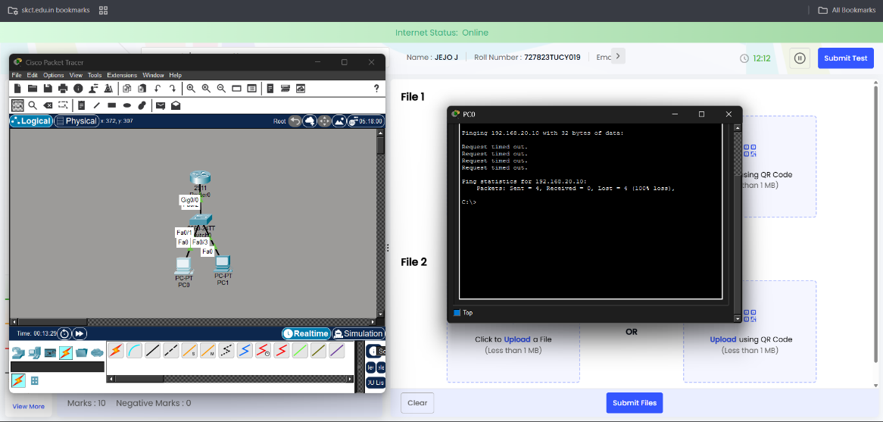
Config on router:
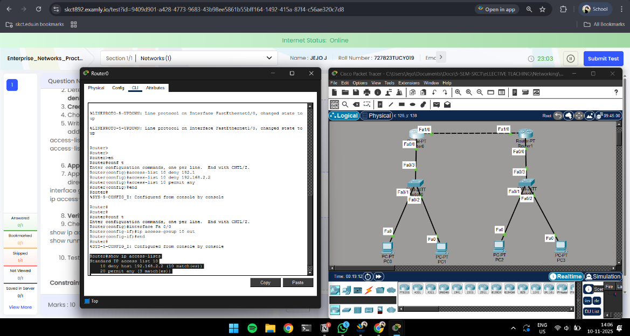

Ping results:
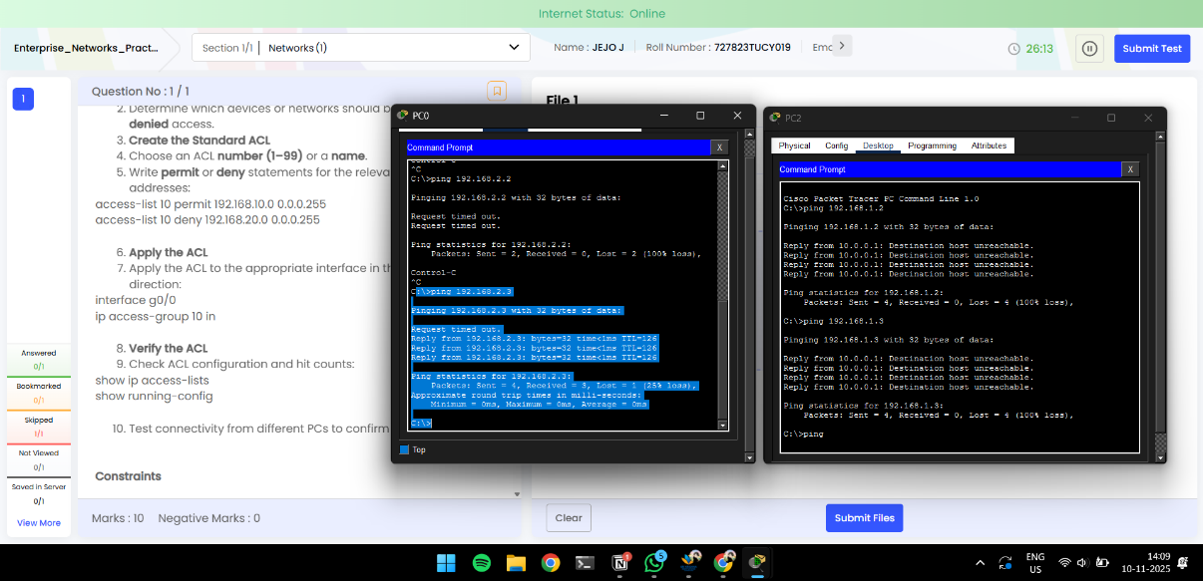

Name: Jejo J
Roll: 727823tucy019

